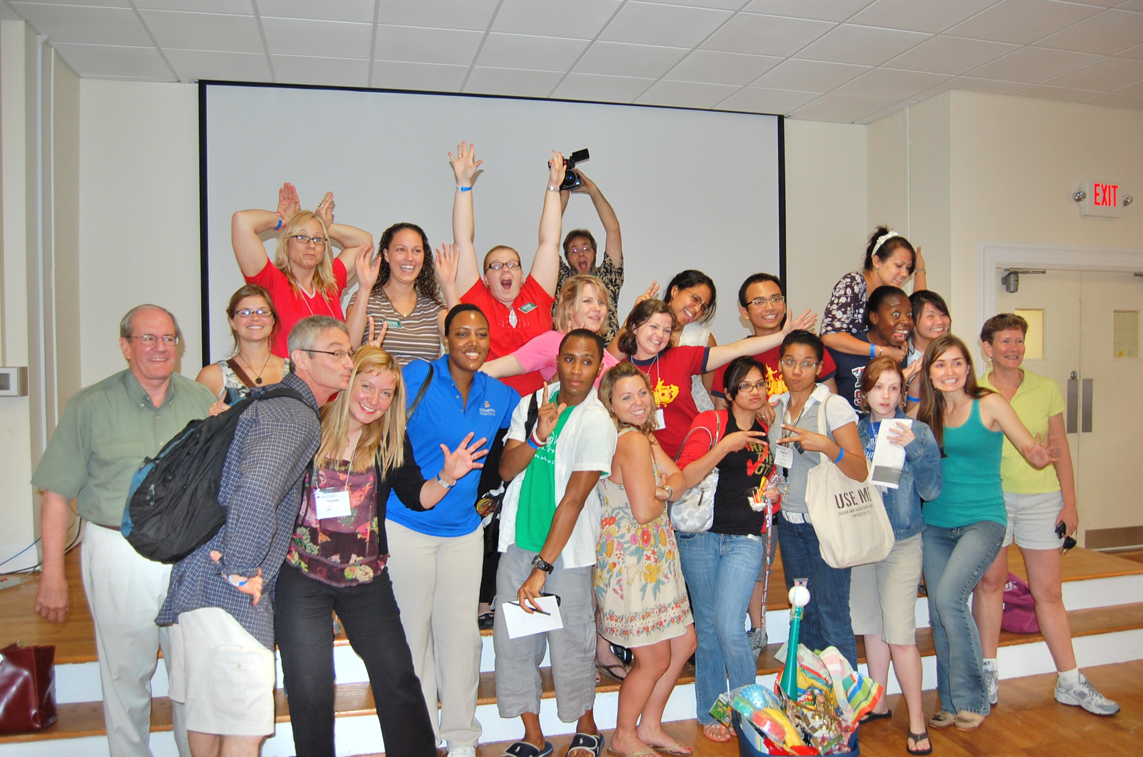

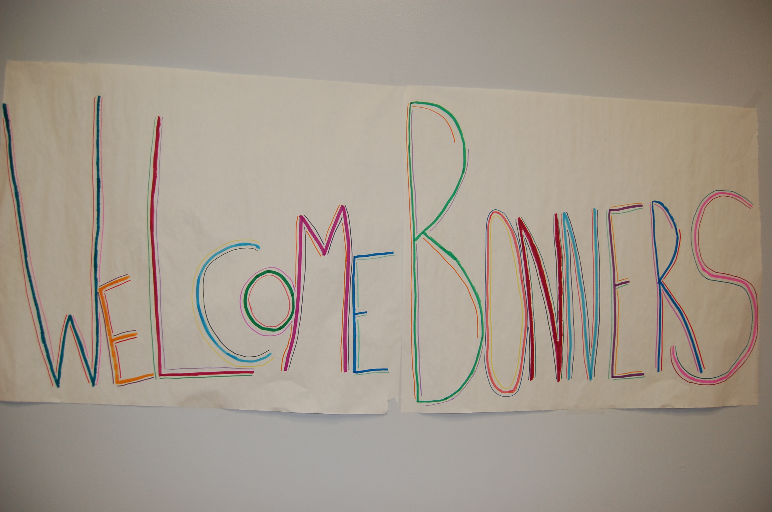

The Bonner
Program
Access to Education, Opportunity to Serve
The Bonner Foundation
10 Mercer Street, Princeton NJ 08540
www.bonner.org
Values & Beliefs
The Bonner Foundation...

is committed to working with all people and institutions regardless of age, race, belief, or nationality.
believes that colleges and congregations have vital societal roles to play by nurturing and mobilizing thoughtful, caring, and diverse leadership dedicated to community service
recognizes that often the best way to help someone is to give them the opportunity to help themselves, and that the people best able to address the problem are the people whom it most directly affects
recognizes that effective community service programs involve all stakeholders in their leadership
recognizes that long-lasting partnerships are based on mutual respect and common commitments
supports innovative programs which have the potential to serve as models for other congregations and higher education institutions
To learn more about the National Bonner Program check us out on our website:
www.bonner.org

For more information on our Campus Bonner Program, please contact:

A Brief Introduction to...
The Bonner Program is a campus-based community service program, through which undergraduate students can work directly with local non-profit organizations in an intensive, sustained manner. Each Bonner Scholar or Leader serves ten hours each week during the academic year, often finding ways to combine their passions in the community with their own study and extra-curricular activities. In addition, students often intern full-time with organizations over the summer.
Supported by the Bonner Foundation, a national philanthropic organization based in Princeton, New Jersey, each Bonner Program works to transform not only the students who are directly supported by the program, but also the campus and community in which they serve and learn. It does this by:
providing access to a college education for students with high financial need and a desire to serve
affording students the opportunity to engage their talents and leadership in strengthening communities
channeling the energies of students, faculty, and staff to make significant contributions to the local community
breaking barriers between town and gown and working to improve people’s lives, the environment, and stronger communities
helping the college create a culture of service so that more are involved in these efforts everyday
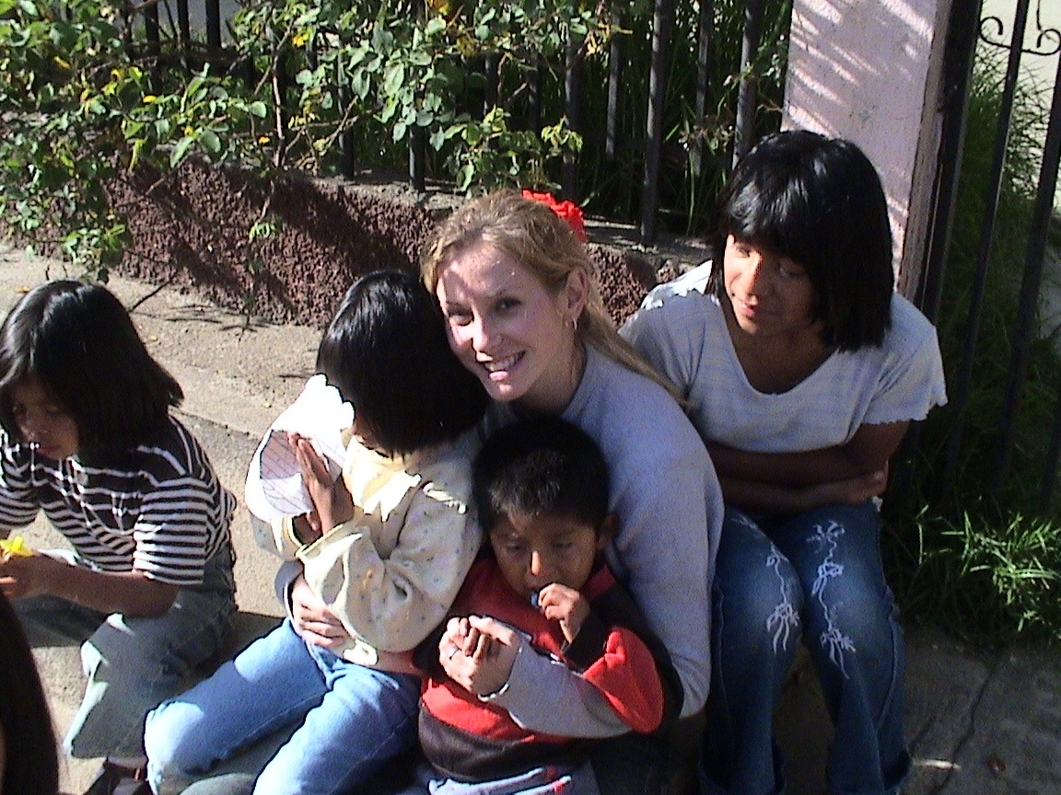

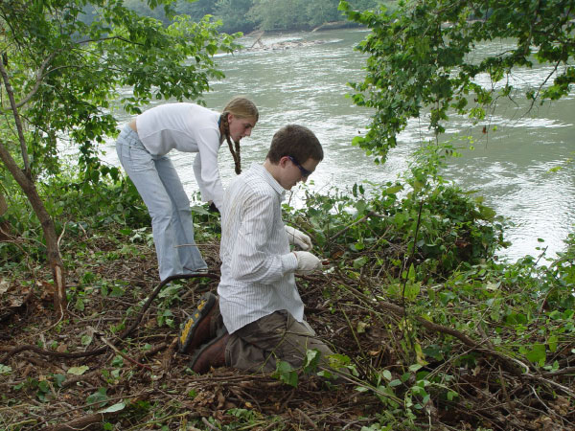

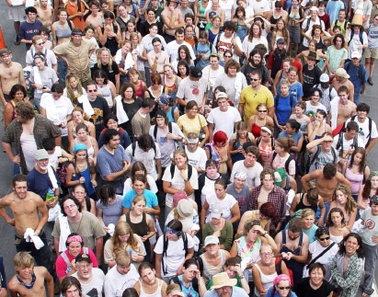

Who is a Bonner Student?
Bonner students are enrolled in American colleges and universities and committed to community service. These students were passionate about serving their communities before college. They have been chosen to receive financial aid or other assistance from the Bonner Program so that they may attend college and continue to positively impact their communities. Most Bonner students come from low-income backgrounds, so the aid is important to their education. Hence, the Bonner Foundation’s motto is Access to Education, Opportunity to Serve; our intensive community service programs provide both.
Bonner Students:
serve 8-10 hours per week in the community
move through a training and enrichment program to supplement their knowledge and skills
are committed to six common commitments
social justice
diversity
community building
spiritual exploration
civic engagement
international perspective

What can a Bonner do for you?
Serving 10 hours per week during multiple academic years, and often full-time in summer, Bonner students gain extensive experience in community service and a passion for addressing pressing societal needs. Veteran Bonners are typically more prepared than the average volunteer to take on more intense roles with your organization, ranging from project coordination to grant writing.
Bonner students are expected to develop their knowledge and skills related to their service work over their four years in college. Their personal development should be reflected in their responsibilities at their service site. Each year, students take on increasingly complex responsibilities with their community partner.
The Bonner Program emphasizes partnerships. By partnering with our campus Bonner program, your organization will:

have access to an experienced volunteer base
gain research opportunities with our academic community on campus
engage in relevant policy analysis with the help of Bonner students’ PolicyOptions project
be connected with a national network of over 80 American colleges and universities and their community partners
Community Partner Guidelines
To facilitate an effective relationship between your organization and a Bonner student, it is highly recommended that someone from your staff is assigned to the student as a manager and mentor to their service. Your Bonner site supervisor will work with the student in creating a Community Learning Agreement (CLA) and sign off on hour logs. It is preferred that the site supervisor be present for the majority of the time that the student is on-site with your organization.

• Community Learning Agreement
The Community Learning Agreement is a thoughtful way for Bonners to consider their own developmental goals in collaboration with the goals of the organization. This agreement is at the core of the partnership, enabling students and service sites to achieve mutually valuable goals.
• Hour Logs
Hour logs are printed time sheets that the student and site supervisor will sign off on to affirm the student’s service hours at your organization. Deadlines are in accordance with the campus program.

